Savitribai Phule Pune University



A

PROJECT Report

On

“AUTOMATED ROTARY STORAGE SYSTEM”

Submitted by:

**Mr. SAURABH SANJAY KSHIRSAGAR (B150070871)**

**Mr. AKSHAY NIVRUTTI NIMBOLE (B150070895)**

Under the Guidance of

**Prof. J. S. Kulkarni**



PVG’S College of Engineering and Technology & G.K. Pate (Wani) Institute of Management

Department of Mechanical Engineering

2021-2022

PVG’S College of Engineering and Technology & G.K. Pate (Wani) Institute of Management

Department of Mechanical Engineering



**CERTIFICATE**

This is certify that **Mr. SAURABH SANJAY KSHIRSAGAR** and **Mr. AKSHAY NIVRUTTI NIMBOLE** of PVG’S College of Engineering and Technology & G.K. Pate (Wani) Institute of Management has submitted the Project Report entitled

“**AUTOMATED ROTARY STORAGE SYSTEM**”

They have satisfactory completed and submitted Project Report as prescribed by Savitribai Phule Pune University for Fourth Year Engineering (Mechanical Engineering) for the Academic Year 2021-2022.

Place: Pune

Date:

Prof. J. S. Kulkarni

Project Guide Internal Examiner

Dr. Manmohan Bhoomkar

Head of Department External Examiner

(Seal)

# Acknowledgment

First and foremost, I would like to thank my guide, Prof. J. S. Kulkarni, for his guidance and support. I will forever remain grateful for the constant support and guidance extended by guide, in making this report. Through our many discussions, he helped us to form and solidify ideas. The penetrating questions he has put to us and the constant motivation, has led to the development of this project.

I wish to express my sincere thanks to the Head of department, Dr. Manmohan Bhoomkar, also grateful thanks to our coordinator Prof. J. S. Kulkarni, and the departmental staff members for their support.

I would also like to thanks to my friends for listening to my ideas, asking questions and providing feedback and suggestions for improving my ideas.

Thanking You,

Mr. SAURABH SANJAY KSHIRSAGAR

Mr. AKSHAY NIVRUTTI NIMBOLE

**Index**

Abstract

1. Introduction …………………………………………………………………..1
   1. problem statement
   2. objective
   3. scope
   4. Methodology
2. Literature Review……………………………………………………………...6
3. Design…………………………………………………………………………13
4. CAD Modelling of an rotary storage system…………………………………26
   1. Frame
   2. Frame assembly
   3. Motor plate
   4. Motor
   5. Shaft
5. Automation Parts…………………………………………………………….30
   1. L239D motor driver
   2. EM-18 module
   3. Arduino UNO
   4. RFID card
6. Bill of Materials……………………………………………………………...33
7. Manufacturing process………………………………………………………..34
8. Arduino code………………………………………………………………….43
9. Conclusion…………………………………………………………………….48

* References…………………………………………………………………….49

**ABSTRACT**

Now days in industry, materials (which are available in raw material, finished parts, assembly parts etc.) are kept in a storeroom with stock and mix-up parts to each other which may be damage. So, secure tools, raw material, manufactured parts, and assembly parts of industry have stored in rotary storage system. This system is very useful for material storage in industrial application. Storage compartments rotate by using chain and sprocket mechanism. It is simple to operate with the employee to store the material in the system at the ground level. Each employee has a unique ID for store material in compartments and retrieved material from compartments. Traditional systems have a major disadvantage of large space consumption and damaging material which is successfully eliminated with the use of a rotary storage system. Moreover, the latter provides the added benefits of flexible operation without the need of an attendant and added security and least chances of material damage. Since the model makes use of composite parts, it is easy to assemble and dismantle and is thus more convenient than the traditional storage systems. The idea is to storage and move material with no disturbance to the already stored material in rotary storage system. Once the employee leaves the incorporated safety zone the system rotating to lift the stored material compartment away from the bottom to central position. This leaves an empty compartment available at the ground level for the next material to be stored in. The stored material is easily retrieved by pushing the button for the relevant position number in which material is stored. This causes the required material compartment to rotate down to ground level ready for the employee of industry to enter the safety zone.

1. **INTRODUCTION**

It is simple to operate with the employee storing material in the system at the ground level. Once the employee leaves the incorporated safety zone the compartment is automatically stored material by the system rotating to lift the stored material compartment away from the bottom central position. This leaves an empty compartment available at the ground level for the next material to be stored in. The stored materials are easily retrieved by pushing the button for the relevant position number of the compartments material stored in. This causes the required compartment to rotate down to ground level ready for the employee to enter the safety zone and receive material out of the system. Except all other systems use a large ground area, Rotary storage System is developed to utilize maximum vertical area in the available minimum ground area. It is quite successful when installed in minimum areas which are well established and are suffering with shortage of area for storing material in industry. Although the construction of this system seems to be easy, it will be par from understanding without the knowledge of materials, chains, sprockets, bearings, and machining operations, kinematic and dynamic mechanism.

The Rotary Storage System for material such as material stored in storeroom, tools and equipment stored in cupboard etc. have been implemented on a huge scale. But these systems have a major disadvantage of large space consumption and worst management of organisation which is successfully eliminated with the use of a rotary storage system. Moreover, the latter provides the added benefits of flexible operation without the need of an attendant and added security and least chances of materials damage. Since the model makes use of composite parts, it is easy to assemble and dismantle and is thus more convenient than the traditional material storing systems. The rotary model is specifically designed to accommodate material separately with less space. The materials are safely store and retrieve uniformly and unique shaped items.

The structure can accommodate six compartments in the space and can even be customized to hold a greater number depending upon the requirements of the organisation. Storage spaces cannot cope with the growth of the different type of the materials. The structure of the system is like a building. The basic structure of the rotary storage system can be described with the help of block diagram.

**Block Diagram:**

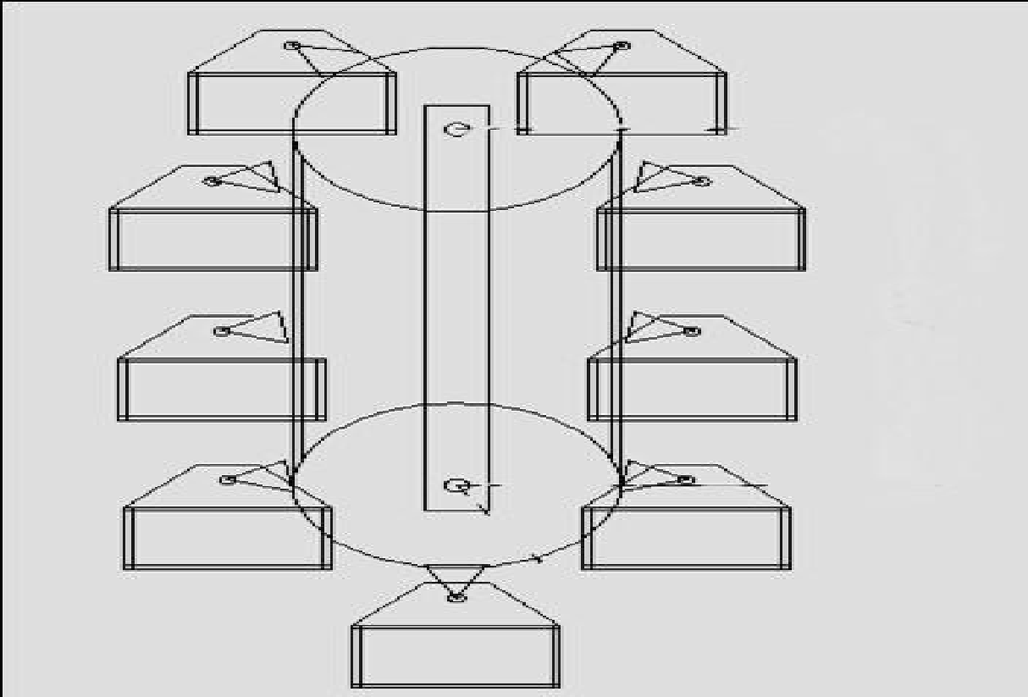

Fig No 1.1 Rotary Storage System [2]

Now days in industry, materials (which are available in raw material, finished parts, assembly parts etc.) are kept in a storeroom with stock and mix-up parts to each other which may be damage. So, secure tools, raw material, manufactured parts, and assembly parts of industry have stored in rotary storage system. This system is very useful for material storage in industrial application. Storage compartments rotate by using chain and sprocket mechanism. It is simple to operate with the employee to store the material in the system at the ground level. Each employee has a unique ID for store material in compartments and retrieved material from compartments. Traditional systems have a major disadvantage of large space consumption and damaging material which is successfully eliminated with the use of a rotary storage system. Moreover, the latter provides the added benefits of flexible operation without the need of an attendant and added security and least chances of material damage. Since the model makes use of composite parts, it is easy to assemble and dismantle and is thus more convenient than the traditional storage systems. The idea is to storage and move material with no disturbance to the already stored material in rotary storage system. Once the employee leaves the incorporated safety zone the system rotating to lift the stored material compartment away from the bottom to central position. This leaves an empty compartment available at the ground level for the next material to be stored in. The stored material is easily retrieved by pushing the button for the relevant position number in which material is stored. This causes the required material compartment to rotate down to ground level ready for the employee of industry to enter the safety zone.

* 1. **Problem Statement**

In industries, material handling and storing system is very time consuming and sometimes are hazardous to workers and organization. Now days in industry, materials are kept in a storeroom with stock and mix-up parts to each other which may be damage. Material stocks should be always necessary in mechanical industries. Materials are in the form of raw material, finished parts, assembly parts and also tools, equipment. These are stored in one or two storeroom in industry which can damage and corrosive. Also time consume process for separate materials which stores at one place, that material are like different shape and size rods, nut and bolts etc. Space is also matter for store material.

**Solution**

So overcome this problem of material handling and storage in industries, we create new technology is rotary storage system which is applicable for material storage and also better management of organization for inventory. This system have used to store raw material, assembly parts, finished parts, tools and equipment separately in system compartment. This system should be less time consuming, expensive and better management in inventory for organization. Rotary storage System is developed to utilize maximum vertical area in the available minimum ground area.

* 1. **Objective**
* To achieve Safety and security – No material damage.
* To achieve save time for material handling in industry.
* To achieve Environment-friendly industries.
* To achieve systematic storing material in separate compartments.
* To achieve better management for organization.
* Improved inventory record accuracy in organization.
  1. **Scope**

Considering different item storage schemes-

The case of independent uniformly distributed items locations is the only known scenario where the travel time can be evaluated analytically by applying a systematic mathematical approach. It is important to develop methods to obtain statistical characteristics of the travel time under more realistic assumptions on the items locations there are not many results in this direction in the literature. The non-uniform distributions of pick positions and especially the correlations between the items in an order lead to challenging mathematical problems. We believe that no feasible analytical solutions can be obtained in most of the realistic models. Thus, the problem calls for well justified heuristics and efficient numerical methods.

* 1. **Methodology**

Flow chart shows the Methodology following for automated shelves. The Automated Shelves is an electrically operated vertical conveyor storage system with an integrated control system to accommodate maximum material while optimizing the space and time for operation and also to ease the process of storing and handling the products stored at inaccessible heights. Following methodology can be used for the Automated Racks.

The Rotary Storage System has following components:

1) Main Frame

2) Electric Motor

3) Chain drive for motor power transmission

4) Transmission Shaft

5) Main Chain drive for Racks

6) Rack to Chain Attachment

7) Racks (Buckets)

8) Control System

Selection of Motor and Shelf

Calculation for Design of hanging transmission chain and main frame

Selection of Chain, Sprocket Bearing and Shaft

Selection of control System

Fabrication of frame, attachment links from chain to the shelf

Assembly of all components

Flow chart 1.2 Methodology of Rotary Storage System

1. **LITERATURE REVIEW**

**Automatic Rotary Storage System using RFID**

Vipul More, KiranRavariya, Sohil Shah, Azharuddin Solkar *Student, Electronics and Telecommunication, Rajiv Gandhi Institute Of Technology, Maharashtra India*

This paper is devoted to make use of control systems in rotary storage systems. The control system is going to play a major role in organizing the entry and the exit for the storage lot. It also presents the design of multi-level storage lots which occupies less need on the ground and contains the large number of components. Therefore, the need of using technologies became inevitable.

Today the storage -space has become a very big problem, it has become very important to avoid the wastage of space in modern big Automatic multilevel industries this system helps to minimize the storage area companies and apartments etc. There are two types of storage systems: the traditional and new automated rotary systems. The automated storage systems are likely to be more cost effective when compared to old traditional storage garages. The multi-storage automated storage systems are less expensive per storage slot, since they require less building space and less ground area than a traditional facility with the same capacity. This paper is devoted to make use of control systems in Storage systems. The control system is going to play a major role in organizing the entry and the exit for the Storage lot. It also presents the design of multi-level Storage lots which occupies less need on the ground and contains the large number of components. Therefore, the need of using technologies became inevitable.

Today the Storage-space has become a very big problem; it has become very important to avoid the wastage of space in modern big Automatic multilevel component Storage system helps to minimize the component Storage area companies and apartments etc. There are two types of component Storage systems: the traditional and new automated Storage systems. The automated component Storage systems are likely to be more cost effective when compared to old traditional Storage garages. The multi storage automated component store systems are less expensive per Storage slot, since they require less building space and less ground area than a traditional facility with the same capacity. Both automated component Storage systems and automated Storage garage systems reduce pollution. A multilevel component Storage is essentially a building with number of floors or levels for the components to be stored.

The different levels are accessed through interior lift system. An automated component Storage has mechanized lifts which transport the component to the different levels at a certain position. Therefore, these component stores require less building volume and less ground space and thus being cost effective. This system saves a lot of space where more than 100 components need to be stored as compared to other systems. This system enables the Storage of material, floor after floor and thus will reduce the space used. Here any number of components can be stored according to the requirement. This makes the systems modern and even a space-saving one. Multi–level component Storage system is essential especially in regions facing space shortages, also in areas which cater huge crowds. Failing to accommodate the growing number of components, it has become important to come up with more efficient and effective Storage solutions.

In this regard, multi-level automated component Storage is going to be considered an effective tool in tackling the issue of Storage. Multi- level component stores also offer great possibility and flexibility for the realization. The main objectives of the component Storage system are- to design and fabricate a multilevel component Storage system and to design and fabricate a cost-effective model, to develop a fully automated control system and to prevent illegally stored material which students work on rotary storage system and give the information. Automated was infrequently built locally, although it did catch on in Asia; there are 1.6 million automated spaces recently in Japan. In the 1980s, one system built in Honolulu was a part of a small office construction on a crowded mixed-use of storage system. Then, in the early 80‟s, automated storage solution were embraced by Japan and USA and spread to Australia, Southeast Asia, China, Philippines and Singapore. Between early 70‟s and late 80‟s, around more than hundred automated systems were built worldwide.

In 20th century the automated storage can be used for multi purposes even though in short term it will come to life again to be implemented and managed by a swipe of d and by many other methods. It will be spread to solve many problems of storage issue and preserve the environments

3. **ISSN: 2319-5967 ISO 9001:2008 Certified International Journal of Engineering Science and Innovative Technology (IJESIT) Volume 4, Issue 2, March 2015**

Chandni Patel, Monalisa Swami, Priya Saxena, Sejal Shah which is take information about Rotary storage System.

The Rotary Automated storage system belongs to the class of rotary smart systems. The traditional storage systems such as multilevel or multi-storage storage systems (non-automated), robot storage systems, automated multilevel storage systems etc. have been implemented on a huge scale. But these systems have a major disadvantage of large space consumption which is successfully eliminated with the use of a rotary storage system. Moreover, the latter provides the added benefits of flexible operation without the need of an attendant and added security and least chances of material damage. Since the model makes use of composite parts, it is easy to assemble and dismantle and is thus more convenient than the traditional storage systems.

The rotary model is specifically designed to accommodate multiple in the horizontal space of two. The structure can accommodate six s in the space of two and can even be customized to hold a greater number depending upon the requirements of the user and can be efficiently put to use in much space crunched areas.

Storage spaces cannot cope with the growth of the number of material. The material stored randomly, because the major problem faced in most of the metropolitan industries. Depicts the interconnection between the various subsystems of the project. Mechanical storage equipment is also called stereo garage. As compared to the existing storage arrangements, the most obvious advantage is maximum space utilization; it is safer and more convenient.

The RTS is totally automated with the user being given a unique ID corresponding to the trolley being allocated to him/her. This kind of equipment is useful to solve the issue of limited storage space available in busy industries. Evidently, it can be seen that the number of private is increasing every year. Private garages, where only a single can be housed at a time, do not provide a feasible solution to the problem since many families own more than one. So the task was to design mechanical equipment that can store 6 s in one normal garage. It is called a rotary storage shaft. The idea is to store and move with no disturbance to the already stored. Automatic multi-stored component Storage system is very good substitute for component Storage area.

The design is obviously an efficient one because compared to other existing design it can handle more components in a limited space. The lifting mechanism is also simpler and cost effective. Two IR sensors TX RX pairs are used in this project to identify the vacant spaces. It is a versatile project with application in almost every field, be it residential or industrial. We would like to conclude this project as a very great and upgradable experience

RFID Tag/Reader RFID is an abbreviation for Radio Frequency Identification. An RFID system consists of two parts .i.e., a reader, and one or more transponders, which are also known as tags. RFID systems have evolved from barcode labels as a means to automatically identify and track products as well as people. In the RACPS, the user is assigned a unique ID corresponding to the specific trolley. This helps in quick identification and movement of the same.

Microcontroller 89S51 The IC AT89S51 is a low-power, high-performance CMOS 8- bit microcontroller and has 4K bytes of in system programmable flash memory. This chip is manufactured using Atmel’s high-density non-volatile memory technology and it is compatible with the industry- standard 80C51 instruction set and pin out.

The on chip flash memory allows the program memory to be reprogrammed in-system or by a conventional non-volatile memory programmer. Microcontroller 89S51 is preferred over 89C51 in this project due to the fact that the former requires 5V for its operation whereas the latter needs to be supplied with 12V. Relay Driver There are 8 NPN Darlington pairs in this family of arrays and are ideally suited for interfacing between low logic level digital circuitry as well as the higher current or voltage requirements of relays, printer hammers or other similar loads for a broad range of applications in computers, industries and consumer applications. It features open–collector outputs and free-wheeling clamp diodes for transient suppression.

LM7805 Series Voltage Regulators a voltage regulator is an electrical device designed to automatically maintain constant voltage levels in a circuit. It makes use of an electromechanical mechanism or passive or active electronic components. Based on the design, it may be used for the regulation of one or more AC or DC voltages. Except the shunt regulators, all voltage regulators operate by first comparing the actual output voltage with some internal fixed reference voltage. The difference, if any, is amplified and used to control the regulation element. This will form a negative feedback servo control loop. If the output voltage is very low, the regulating element is commanded to produce a higher voltage. If the output voltage is very high, the regulating element is commanded to produce a lower voltage. In this way, the output voltage is maintained roughly constant.

The software is responsible for taking into consideration the sensor data and gives the required output signal to the linear control system. For this, we require an action perception loop, sensor polling and controlling movement. We have selected microcontroller 89S51 and the code for it is written in Embedded Basic language. The programming of the microcontroller has been accomplished by using the “Bascom Compiler” (BC) software. It has been designed to execute codes on W95/W98/NT/W2000/XP versions and Vista. The Embedded Basic language code has been successfully executed and programmed into the microcontroller IC 89S51.

The BC is structured basic with labels. It supports structured programming with if-then-else-end if, dollop, while-when, select- case. Variables and labels in BC can be as long as 32 characters. Bit, Byte, Integer, Word, Long, Single and String variables. Processors The Compiled programs work with any 8051 microcontroller such as AT89C1051, AT89C2051, 8031, 8032, 8051, 8052, 80552, 80535 and 80537.There are special commands for LCD-displays, I2C chips and 1WIRE chips. BC has integrated terminal emulator with download option .Integrated simulator for testing .It is integrated flash programmer and also supports SPI, PG2051, PG302, SE512, SE514, TAFE and many more. It is context sensitive. For compatibility with BASCOM LT. To make a p

**4. International Journal of Emerging Technology and Advanced Engineering Website: www.ijetae.com (ISSN 2250-2459, ISO 9001:2008 Certified Journal, Volume 5, Issue 4, April 2015)**

This paper consists of more details related to rotary storage system it is simple to operate with the driver storage and leaving the material in the system at the ground level. Once the driver leaves the incorporated safety zone the material is automatically stored by the system rotating to lift the stored away from the bottom central position. This leaves an empty storage space available at the ground level for the next to be stored on.

The stored is easily retrieved by pushing the button for the relevant position number the is stored on. This causes the required to rotate down to ground level ready for the driver to enter the safety zone and reverse the out of the system. Except vertical storage system all other systems use a large ground area, vertical storage system is developed to utilize maximum vertical area in the available minimum ground area. It is quite successful when installed in busy areas which are well established and are suffering with shortage of area for storage. Although the construction of this system seems to be easy, it will be par from understanding without the knowledge of materials, chains, sprockets, bearings, and machining operations, kinematic and dynamic mechanisms imagine the time that automatic smart storage systems would save you.

Every time you enter your office building you have to find a storage space and spend time walking in and out of the lot as well. Imagine how much time it is costing you. Even if you just spend 5 minutes a day to store that translates to you spending more than a whole day just storage every year. If you calculate the time you spend walking in and out of the storage lot, searching for space and such it will be easily more than the above amount. A fully automated system mimics a futuristic assembly line structure where they are moved to an empty platform.

The earliest known multistage component Storage system was built in 1918. It was built for the Hotel La Salle in Chicago. IL at 215 West Washington Street in the West Loop area of downtown. It was designed by Holabird and Roche. The Hotel La Salle was demolished in 1976, but the Storage structure remained because it had been designated as preliminary landmark status and the structure was located several blocks from the hotel it was built to service. The Hotel LaSalle multilevel was demolished in 2005 after failing to receive landmark status from the city of Chicago. Jupiter Realty Corp. of Chicago is constructing a 49-level apartment tower in its place with construction underway as of March 2008. During the 1920’s and 1930’s a series of other patents were granted but it was not until the late 1940’s that the Bowser, Pigeon Hole and Roto Store systems became operational and installed in numerous locations. Some of these early systems were vertical elevator lift modules that placed components on upper levels of a structure to be moved by attendant and others mechanical devices that could move material into “slots” in a framework built around a central corridor. Capa industries ranged typically from less than 100 spaces to more than 600. Automated component stores rely on similar technology that is used for mechanical handling and document retrieval. The driver leaves the component in an entrance module. It is then transported to a Storage slot by a robot trolley.

For the driver, the process of Storage is reduced to leaving the component inside an entrance module. At peak periods a wait may be involved before entering or leaving. The wait is due to the fact that loading passengers and luggage occurs at the entrance and exit location rather than at the stored stall. This loading blocks the entrance or exit from being available to others. Whether the retrieval of material is faster in an automatic component store or a self-store component store depends on the layout and number.

Imagine the time that automatic multistage Storage systems would save you. Every time you enter your office building you have to find a Storage space and spend time walking in and out of the lot as well. Imagine how much time it is costing you. Even if you just spend 5 minutes a day to store that translates to you spending more than a whole day just Storage every year. If you calculate the time you spend walking in and out of the Storage lot, searching for space and such it will be easily more than the above amount. A fully automated system mimics a futuristic assembly line structure where the components are moved to an empty platform. The platform under the component moves to a designated spot and all the other platforms are arranged so that no components are stuck.

1. **DESIGN**

A chain drive consists of an endless chain wrapped around two sprockets as shown in Fig. 1. A chain can be defined as a series of links connected by pin joints. The sprocket is a toothed wheel with a special profile for the teeth. The chain drive is intermediate between belt and gear drives. It has some features of belt drives and some of gear drives.

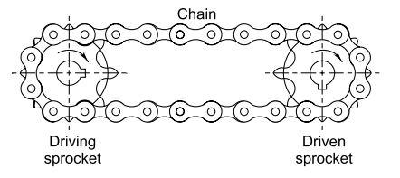

Fig 1 chain drive [3]

Important tables required for the chain selections & design from design data book.

Table 3.1 Power rating of simple roller chain [Design Data Book V.B. Bhandari]

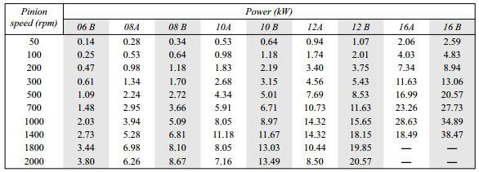

Table 3.2 Dimensions and breaking loads of roller chains[Design Data Book V.B. Bhandari]

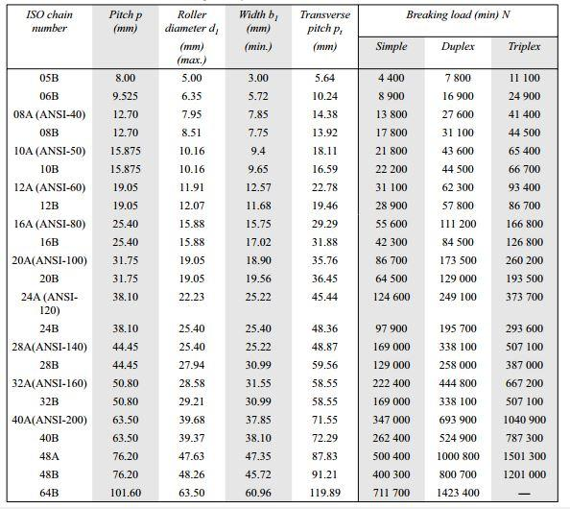

Table 3.3 Service factor (Ks)[Design Data Book V.B. Bhandari]

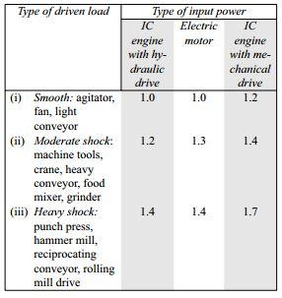

Table 3.4 Tooth correction factor (K2)[Design Data Book V.B. Bhandari]

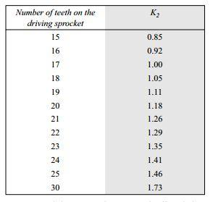

Table3.5 Multiple strand factor (K1)[Design Data Book V.B. Bhandari]

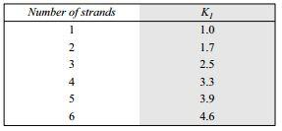

**Given data**

Torque acting on the motor is T= 10 kg= 98.06 N.m.

RPM = 100rpm

* 1. **Design of chain-sprocket:**

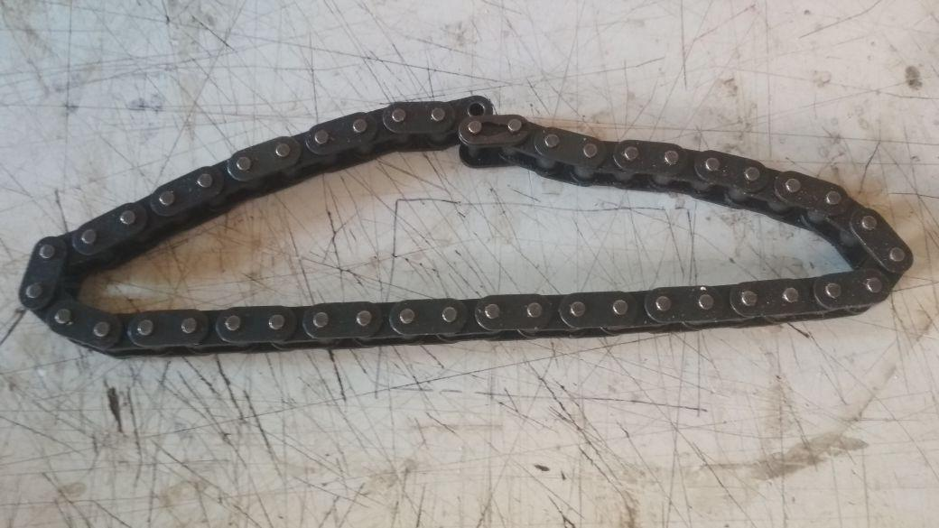

Snap No.3.6 Chain[4]

Let, Number of teeth = Z1= 20 (sprocket)

The number of teeth for the both sprocket are same because we will have to transmit same power to another axis.

Tooth correction factor (K) for the both sprocket K2 = 1.18

From the table 3.4 (tooth correction factor)

Multiple strand factor for strand 1) k1=1

From table 3.5 (Multiple strand factor)

From the table 3.2 (service factor)

For smooth chain & DC motor Ks=1.0s

*We required power transmitted for the further calculations

**Power (P)**

P=

P=

P=1026.63 W

KW Rating of Chain =

=

Power rating= 870.23W= .870 KW

Larger value for 100 rpm in table 3.1 is 0.98

For 100 rpm & Power 0.98 KW

From table 3.1 Power rating of simple roller chain

The Power rating at 10 A is 100rpm & .98 KW power

Therefore chain number 10 A is selected.

From table 3.2

For chain number 10 A

**Dimensions:**

Pitch (P) P=12.70 mm

Roller diameter (d1) d1=8.51 mm (max.)

Width (b1) b1=7.75mm

Transverse Pitch (Pt) Pt=13.92mm

Breaking load

Simple = 17800 N

Duplex = 31100 N

Triplex = 44500 N

Pitch Circle diameter of driving & driven shaft (PCD)

D1== = 81.41 = 85 mm

For driving sprocket D1= 85mm

For driven sprocket D2= 85mm

Number of chain link (Ln)

The central distance between sprocket wheels should between 30P to 50 P

By taking the minimum value

Approximate central distance (a) a= 31P

a=31*12.70

a=393.23

=395mm

Ln = 2 *

= 2 *

= 2 *

= 82.20

No of links are 83

**Correct central distance**

[ Ln -()] = [83-()] = 63

a= }

a=

a= 400 mm

To provide small sag, for allowing the chain links to take the best position on the sprocket teeth, the centre distance is reduced by (0.002a). Therefore, the correct centre distance is given by

a= 0.998*400

a=399mm

To calculate tension in chain

The chain velocity is given by

V=

V= 0.423 m/s

The chain tension is given by

Factor of safety

FS=

FS=10.6077

* 1. **Shaft design**

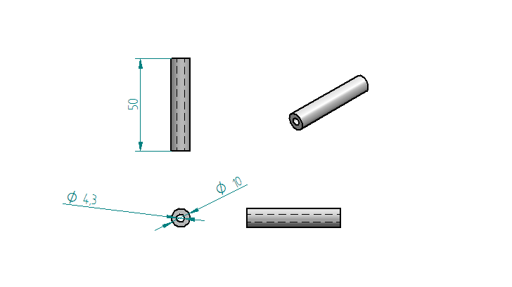

Fig No 3.7 Shaft [3]

**Specification:**

Material of shaft is Mild steel

Material properties of mild steel

Table No.3.8 Properties of Mild Steel

|  |  |  |
| --- | --- | --- |
| Yield strength | Syt | 247MPa , N/mm2 |
| Ultimate tensile strength | Sut | 841 Mpa, N/mm2 |
| Factor of safety | FS | 2 |
| Poisons ratio |  | .303 |
|  |  | 180° |

For chain drive max tension   
2.056KN

**Permissible shear stress**

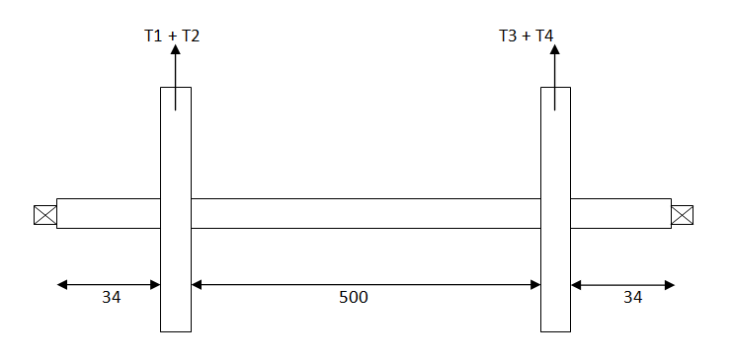

Fig 3.9 Loading Diagram

**Torsion moment**

2.056KN

Torque supplied to the shaft is given by

Mt1= (T1-T2)* 85/2

= (2055.11-793.28) *85/2

= 53670.27 N.mm

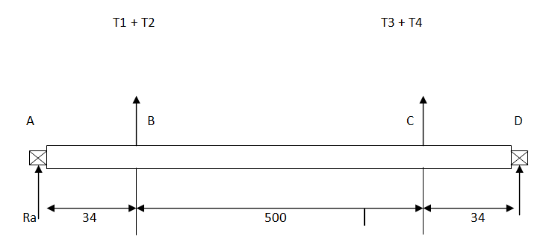

Fig 3.10 Free Body Diagram (FBD)

**Bending moment**

Also Mt2 = (T3-T4)* r

= (2055.11-793.28) *85/2

= 53670.27 N.mm

T3=2055.11 N

T4=793.28 N

Both sprockets are same

Neglecting the wt of sprocket

Force on sprocket 1 at pt. B

F1 = T1+T2

= 2055.11+793.28

= 2850.63 N

Similarly force on the other sprocket at pt. c

F2 = T3+T4

= 2055.11+793.28

= 2850.63 N

Now find out the reactions at support

2848.39+2848.39= RA+RD

2848.39*37+2848.39*337= RD * 374

RD=2848.39 N

From equation 1

RA=2848.39 N

Bending moment at pt. B

(Mb)B = Ra*37

= 2848.39*37

= 105473.31 N.mm

Bendingw moment at pt. c

(Mb)C = RA*337-2848.39*300

= (2848.39*337)-(2848.39*300)

= 105390.43 N. mm

Bending moment at pt. a & d

(Mb) a, d=0 N.mm

Gig d shows the bending moment diagram

105390.43 N-mm 105390.43 N-mm

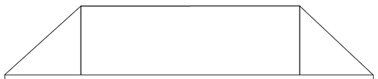

0 0

Fig 3.11 Bending Moment Diagram

Shaft diameter,

151.38 =*

D =15

Taking safe value diameter of shaft is 16 mm

1. **CAD MODELLING OF AN ROTARY STORAGE SYSTEM:**

**Parts**

* 1. **Frame**

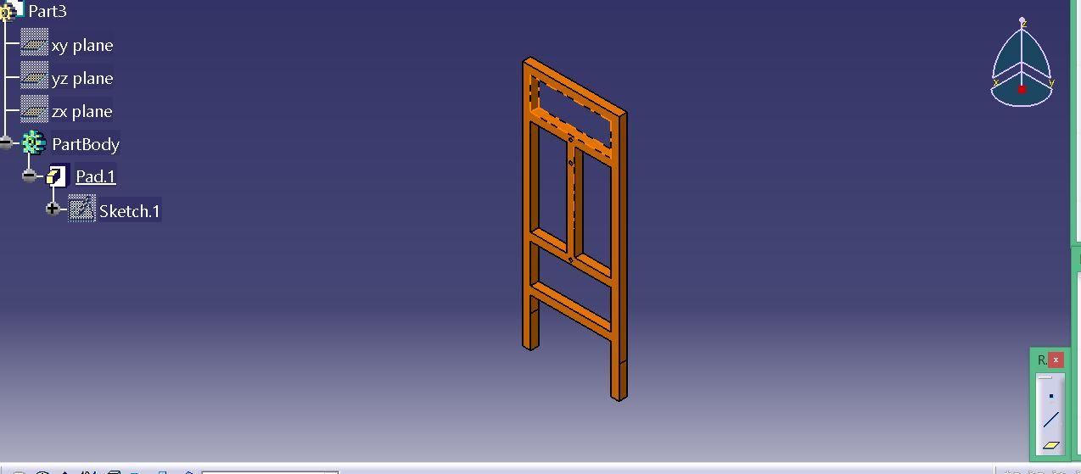

Fig 4.1 Frame of rotary storage system

As per the design the central distance between the sprockets is about 400 mm & we need to left the 140 mm distance up & down for the free rotation of storage shell. So we consider the hieght of the frame 670 mm & width of stand 430 & length 300mm.

To create catia model we used some commands. First we draw a profile of frame & then pad it up to 25 mm.

Coze c/s of frame is 25*25. Then join the both frame by connecting a bar between them.

**4.2 FRAME ASSEMBLY**

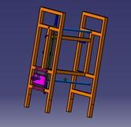

Fig 4.2 Frame Assembly

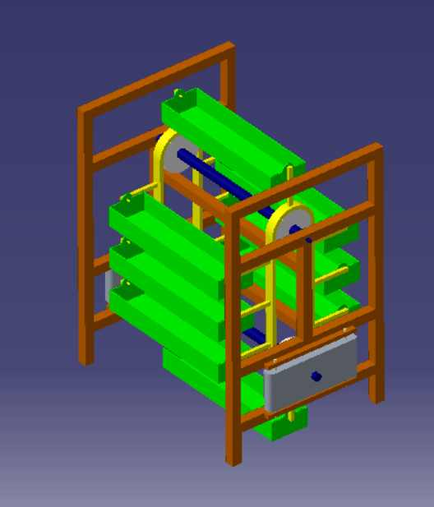

CAD Model

* 1. **Motor Plate**

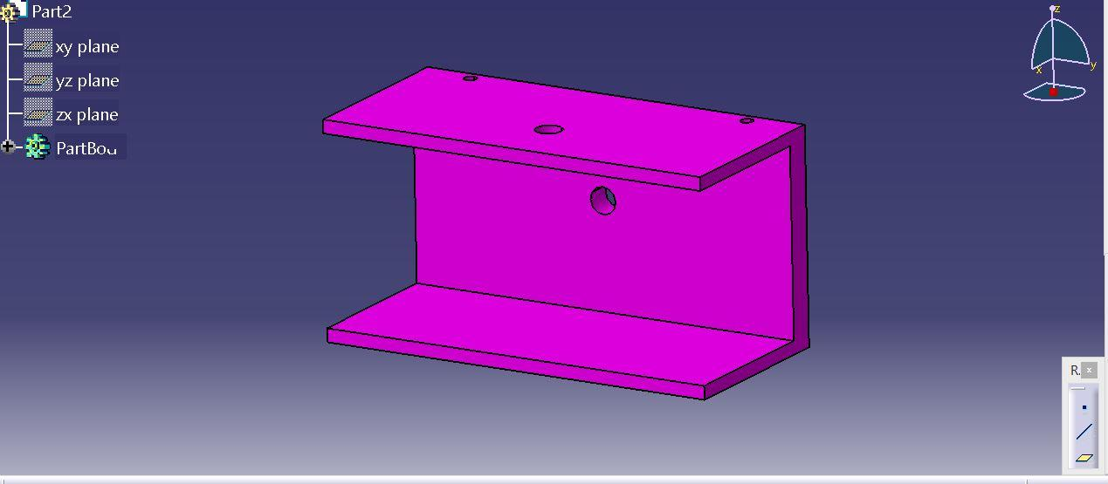

Fig 4.2 Motor Plate of Storage System

The motor plate is used to fix the motor to drive the shaft. To create this part we used the pad & pocket command.

First we draw the Profile like C & Pad it

* 1. **Motor**

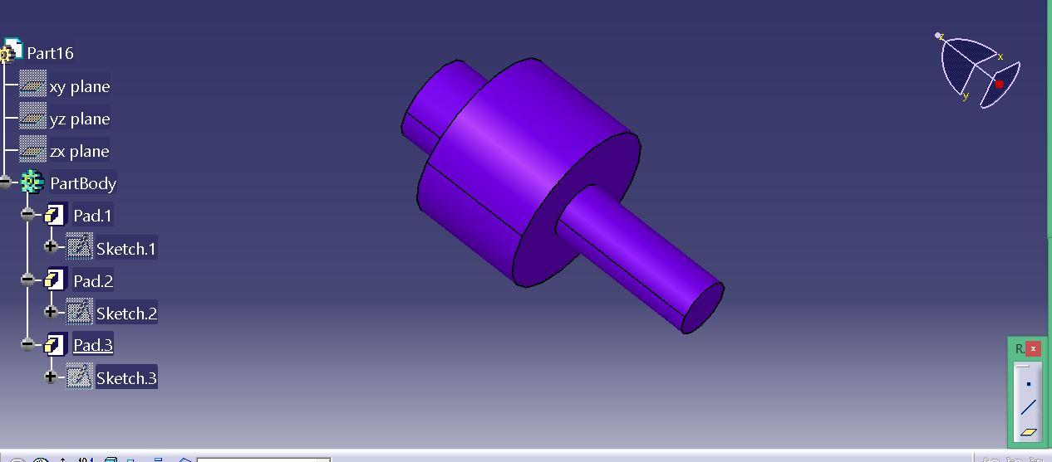

Fig 4.3 Motor Of Rotary Storage System

For the part motor & shaft we use shaft command about x axis.

* 1. **Shaft**

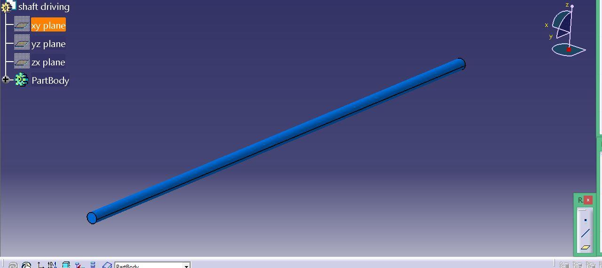Fig 4.4 Shaft of Rotary Storage System

**DRAFTING**

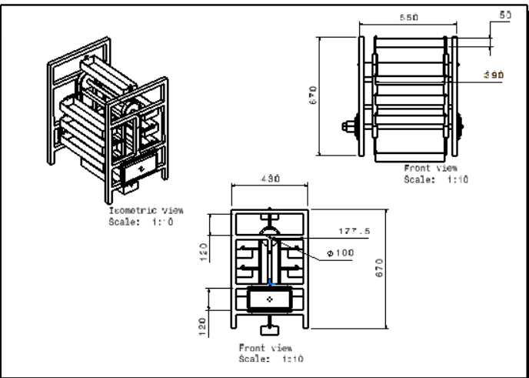

1. **AUTOMATION PARTS**
   1. **L293D Motor Driver**

L293D is a typical Motor driver or Motor Driver IC which allows DC motor to drive on either direction. L293D is a 16-pin IC which can control a set of two DC motors simultaneously in any direction. It means that you can control two [DC motor](https://www.rakeshmondal.info/High-Torque-Motor-Low-RPM-Motor) with a single L293D IC.

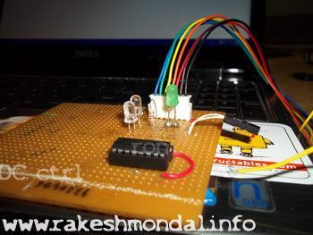

**Fig No 5.1 L293D [8]**

* 1. **EM-18 Module**



Fig No 5.2 EM 18 Module [8]

EM18 RFID Reader is a module which reads the ID information stored in TAGS. This ID information is unique for every TAG which cannot be copied.

### EM-18 Features and Specifications

* Operating  voltage of EM-18: +4.5V to +5.5V
* Current consumption:50mA
* Can operate on LOW power
* Operating temperature: 0ºC to +80ºC
* Operating frequency:125KHz
* Communication parameter:9600bps
* Reading distance: 10cm, depending on TAG
* Integrated Antenna

**EM-18** is used like any other sensor module. First we choose the mode of communication between MODULE and CONTROLLER. Next we will program the controller to receive data from module to display. Next power the system. When a tag is brought near the MODULE it reads the ID and sends the information to controller. The controller receives the information and performs action programmed by us.

* 1. **Arduino Uno**

Arduino is an open-source electronics platform based on easy-to-use hardware and software. [Arduino boards](https://www.arduino.cc/en/Main/Products) are able to read inputs - light on a sensor, a finger on a button, or a Twitter message - and turn it into an output - activating a motor, turning on an LED, publishing something online. You can tell your board what to do by sending a set of instructions to the microcontroller on the board. To do so you use the [Arduino programming language](https://www.arduino.cc/en/Reference/HomePage) (based on [Wiring](http://wiring.org.co/)), and [the Arduino Software (IDE)](https://www.arduino.cc/en/Main/Software), based on [Processing](https://processing.org/).

Over the years Arduino has been the brain of thousands of projects, from everyday objects to complex scientific instruments. A worldwide community of makers - students, hobbyists, artists, programmers, and professionals - has gathered around this open-source platform, their contributions have added up to an incredible amount of [accessible knowledge](http://forum.arduino.cc/) that can be of great help to novices and experts alike.

Arduino was born at the Ivrea Interaction Design Institute as an easy tool for fast prototyping, aimed at students without a background in electronics and programming. As soon as it reached a wider community, the Arduino board started changing to adapt to new needs and challenges, differentiating its offer from simple 8-bit boards to products for IoT applications, wearable, 3D printing, and embedded environments. All Arduino boards are completely open-source, empowering users to build them independently and eventually adapt them to their particular needs. The [software](https://www.arduino.cc/en/Main/Software), too, is open-source, and it is growing through the contributions of users worldwide.

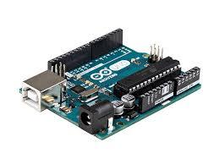

Fig no 5.3 Arduino UNO [8]

**5.4 RFID Card**

RFID tags are a type of tracking system that uses smart barcodes in order to identify items. [RFID is short for](https://www.camcode.com/asset-tags/what-is-rfid/) “radio frequency identification,” and as such, RFID tags utilize radio frequency technology. These radio waves [transmit data](https://www.camcode.com/asset-tags/what-is-rfid/) from the tag to a reader, which then transmits the information to an RFID computer program. RFID tags are frequently used for merchandise, but they can also be used to track vehicles, pets, and even patients with Alzheimer’s disease. An RFID tag may also be called an RFID chip.

0

Fig No 5.4 RFID Card [8]

**6. BILL OF MATERIALS**

|  |  |  |  |  |
| --- | --- | --- | --- | --- |
| Sr. No. | Component Name | Cost | Quantity | Total |
| 1 | Chain and Sprocket | 600 | 2 | 1200 |
| 2 | Lead Screw | 500 | 2 | 1000 |
| 3 | Frame | 3000 | 1 | 3000 |
| 4 | Arduino UNO | 500 | 1 | 500 |
| 5 | EM 18 Module | 800 | 1 | 800 |
| 6 | L293D | 200 | 1 | 200 |
| 7 | Keypad | 100 | 1 | 100 |
| 8 | RFID Card | 20 | 8 | 200 |
| 9 | DC Motor | 180 | 1 | 180 |
| 10 | Connecting Pipe | 210 | 1 | 210 |
|  |  |  | Total Cost | 7350 |
|  |  |  | 18% GST | 1323 |
|  |  |  |  | 8673 |

**7. MANUFACTURING PROCESS**

**PROCESS SHEET:**

Following operations were while fabricate the project

**Cutting: -**

Cutting is the separation or opening of a physical object, into two or more portions, through the application of an acutely directed [force](https://en.wikipedia.org/wiki/Force).

Implements commonly used for [cutting](https://en.wiktionary.org/wiki/cut) are the [knife](https://en.wikipedia.org/wiki/Knife) and [saw](https://en.wikipedia.org/wiki/Saw), or in medicine and science the [scalpel](https://en.wikipedia.org/wiki/Scalpel) and [microtome](https://en.wikipedia.org/wiki/Microtome). However, any sufficiently sharp object is capable of cutting if it has a [hardness](https://en.wikipedia.org/wiki/Hardness) sufficiently larger than the object being cut, and if it is applied with sufficient force. Even liquids can be used to cut things when applied with sufficient force (see [water jet cutter](https://en.wikipedia.org/wiki/Water_jet_cutter)).

The material as our required size. The machine used for this operation is power chop saw. A power chop saw, also known as a drop saw, is a power tool used to make a quick, accurate crosscut in a work piece at a selected angle. Common uses include framing operations and the cutting of moulding. Most chop saws are relatively small and portable, with common blade sizes ranging from eight to twelve inches.

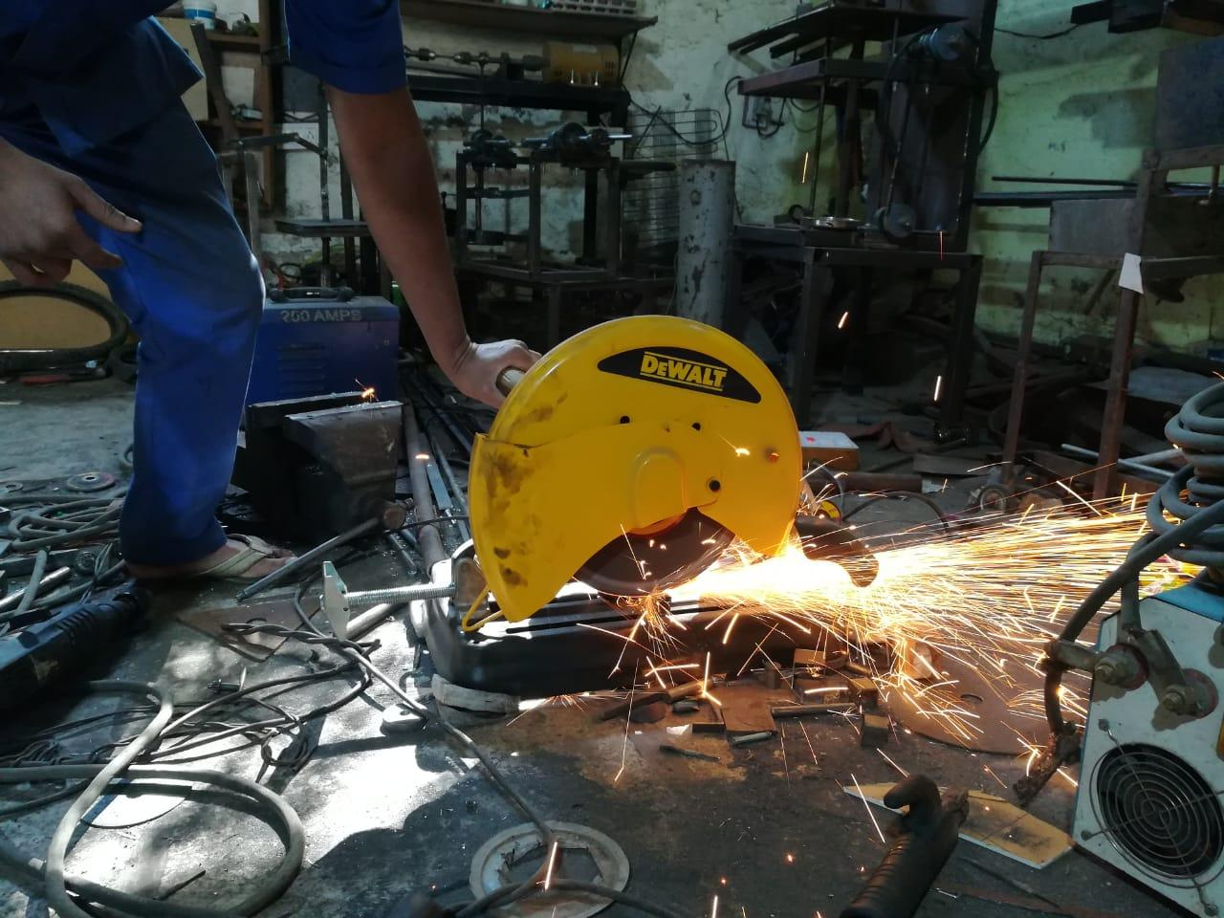

The chop saw makes cuts by pulling a spinning circular saw blade down onto a work piece in a short, controlled motion. The work piece is typically held against a fence, which provides a precise cutting angle between the plane of the blade and the plane of the longest work piece edge. In standard position, this angle is fixed at 90°. A primary distinguishing feature of the mitre saw is the mitre index that allows the angle of the blade to be changed relative to the fence. While most mitre saws enable precise one-degree incremental changes to the mitre index, many also provide "stops" that allow the miter index to be quickly set to common angles (such as 15°, 22.5°, 30°, and 45°). The time required for this operation is 50 minutes.

**Welding: -**

Welding is a [fabrication](https://en.wikipedia.org/wiki/Fabrication_(metal)) or [sculptural](https://en.wikipedia.org/wiki/Welded_sculpture) [process](https://en.wikipedia.org/wiki/Process_(science)) that joins materials, usually [metals](https://en.wikipedia.org/wiki/Metal) or [thermoplastics](https://en.wikipedia.org/wiki/Thermoplastic), by using high [heat](https://en.wikipedia.org/wiki/Heat) to melt the parts together and allowing them to cool causing [fusion](https://en.wikipedia.org/wiki/Fusion_welding). Welding is distinct from lower temperature metal-joining techniques such as [brazing](https://en.wikipedia.org/wiki/Brazing) and [soldering](https://en.wikipedia.org/wiki/Soldering), which do not [melt](https://en.wikipedia.org/wiki/Melting) the base metal.

In addition to melting the base metal, a filler material is typically added to the joint to form a pool of molten material (the [weld pool](https://en.wikipedia.org/wiki/Weld_pool)) that cools to form a joint that, based on weld configuration (butt, full penetration, fillet, etc.), can be stronger than the base material (parent metal). [Pressure](https://en.wikipedia.org/wiki/Pressure) may also be used in conjunction with heat, or by itself, to produce a weld. Welding also requires a form of shield to protect the filler metals or melted metals from being contaminated or [oxidized](https://en.wikipedia.org/wiki/Oxidation).

Square pipes of different lengths to make frame. The machine used for this operation is electric arc welding. Electrical arc welding is the procedure used to join two metal parts, taking advantage of the heat developed by the electric arc that forms between an electrode (metal filler) and the material to be welded. The welding arc may be powered by an alternating current generator machine (welder). This welding machine is basically a single-phase static transformer Suitable for melting RUTILE (sliding) acid electrodes. Alkaline electrodes may also be melted by alternating current if the secondary open-circuit voltage is greater than 70 V.

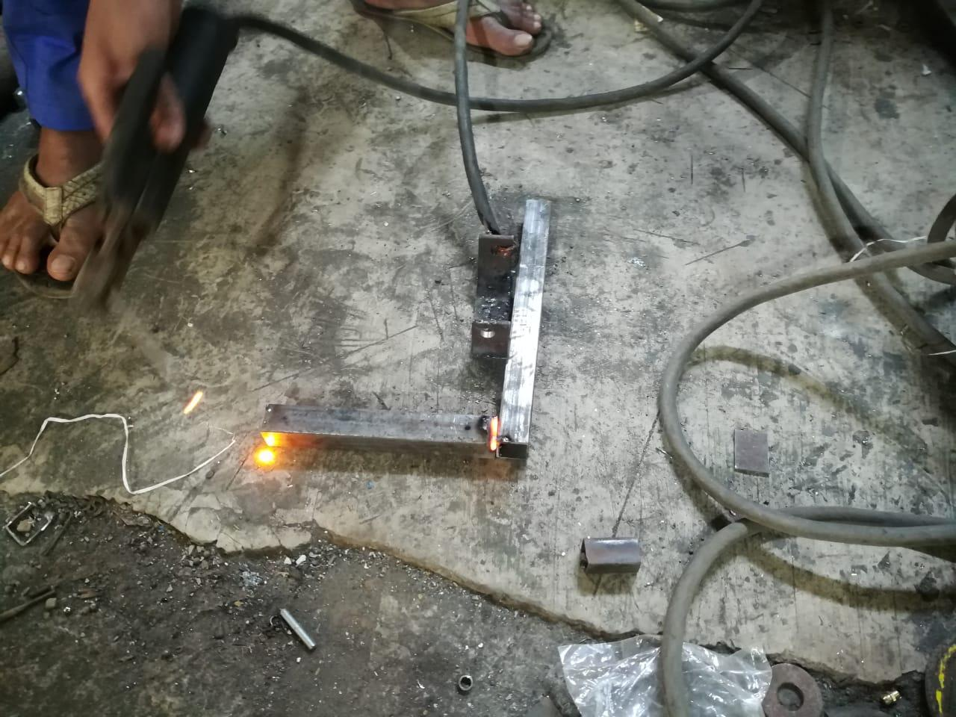

The welding current is continuously regulated (magnetic dispersion) by turning the hand wheel on the outside of the machine, which makes it possible to select the current value, indicated on a special graded scale, with the utmost precision. To prevent the service capacities from being exceeded, all of our machines are fitted with an automatic overload protection which cuts of the power supply (intermittent use) in the event of an overload. The operator must then wait for a few minutes before returning to work. This welding machine must be used only for the purpose described in this manual. Read the entire contents of this manual before installing, using or servicing the equipment, paying special attention to the chapter on safety precautions. Contact your distributor if you do not fully understand these instructions. The time required for this operation is 120 minutes.

**Drilling: -**

Drilling is a [cutting](https://en.wikipedia.org/wiki/Cutting) process that uses a [drill bit](https://en.wikipedia.org/wiki/Drill_bit) to cut a hole of circular [cross-section](https://en.wikipedia.org/wiki/Cross_section_(geometry)) in solid materials. The drill bit is usually a rotary [cutting tool](https://en.wikipedia.org/wiki/Cutting_tool_(machining)), often multi-point. The bit is [pressed](https://en.wikipedia.org/wiki/Pressure) against the work-piece and rotated at rates from hundreds to thousands of [revolutions per minute](https://en.wikipedia.org/wiki/Revolutions_per_minute). This forces the cutting edge against the work-piece, cutting off [chips (swarf)](https://en.wikipedia.org/wiki/Swarf) from the hole as it is drilled.

In [rock](https://en.wikipedia.org/wiki/Rock_(geology)) drilling, the hole is usually not made through a circular cutting motion, though the bit is usually rotated. Instead, the hole is usually made by hammering a drill bit into the hole with quickly repeated short movements. The hammering action can be performed from outside the hole ([top-hammer drill](https://en.wikipedia.org/w/index.php?title=Top-hammer_drill&action=edit&redlink=1)) or within the hole ([down-the-hole drill](https://en.wikipedia.org/wiki/Down-the-hole_drill), DTH). Drills used for horizontal drilling are called [drifter drills](https://en.wikipedia.org/wiki/Drifter_drill).

In rare cases, specially-shaped bits are used to cut holes of non-circular cross-section; a [square](https://en.wikipedia.org/wiki/Square_(geometry)) cross-section is possible.

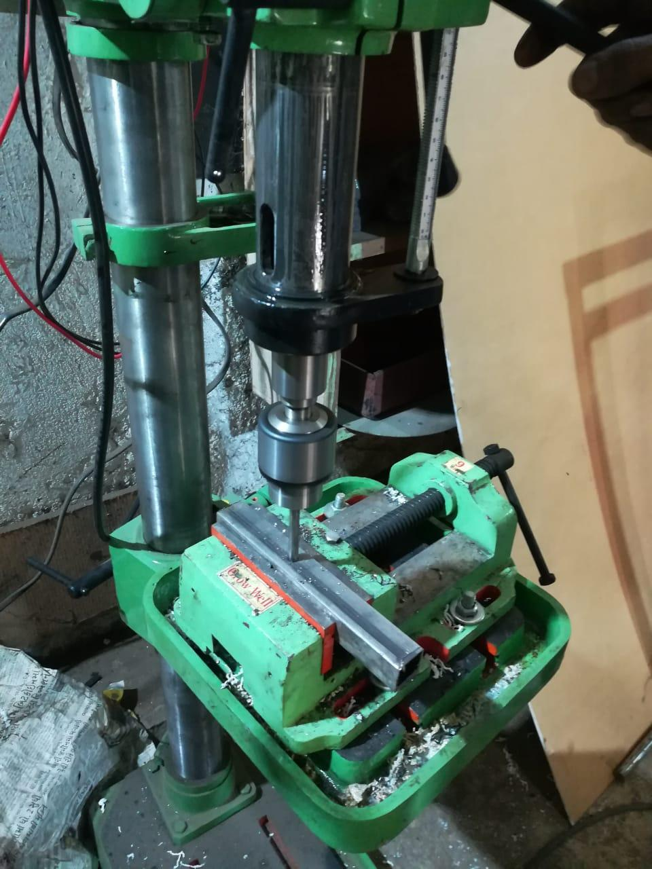

Drilled holes are characterized by their sharp edge on the entrance side and the presence of [burrs](https://en.wikipedia.org/wiki/Burr_(metal)) on the exit side (unless they have been removed). Also, the inside of the hole usually has helical feed marks.

Drilling may affect the mechanical properties of the work piece by creating low [residual stresses](https://en.wikipedia.org/wiki/Residual_stress) around the hole opening and a very thin layer of highly [stressed](https://en.wikipedia.org/wiki/Stress_(mechanics)) and disturbed material on the newly formed surface. This causes the work piece to become more susceptible to [corrosion](https://en.wikipedia.org/wiki/Corrosion) and [crack propagation](https://en.wikipedia.org/wiki/Crack_propagation) at the stressed surface. A finish operation may be done to avoid these detrimental conditions.

For [fluted](https://en.wikipedia.org/wiki/Flute_(cutting_tool)#Flute) drill bits, any chips are removed via the flutes. Chips may form long spirals or small flakes, depending on the material, and process parameters. The type of chips formed can be an indicator of the [machinability](https://en.wikipedia.org/wiki/Machinability) of the material, with long chips suggesting good material machinability.

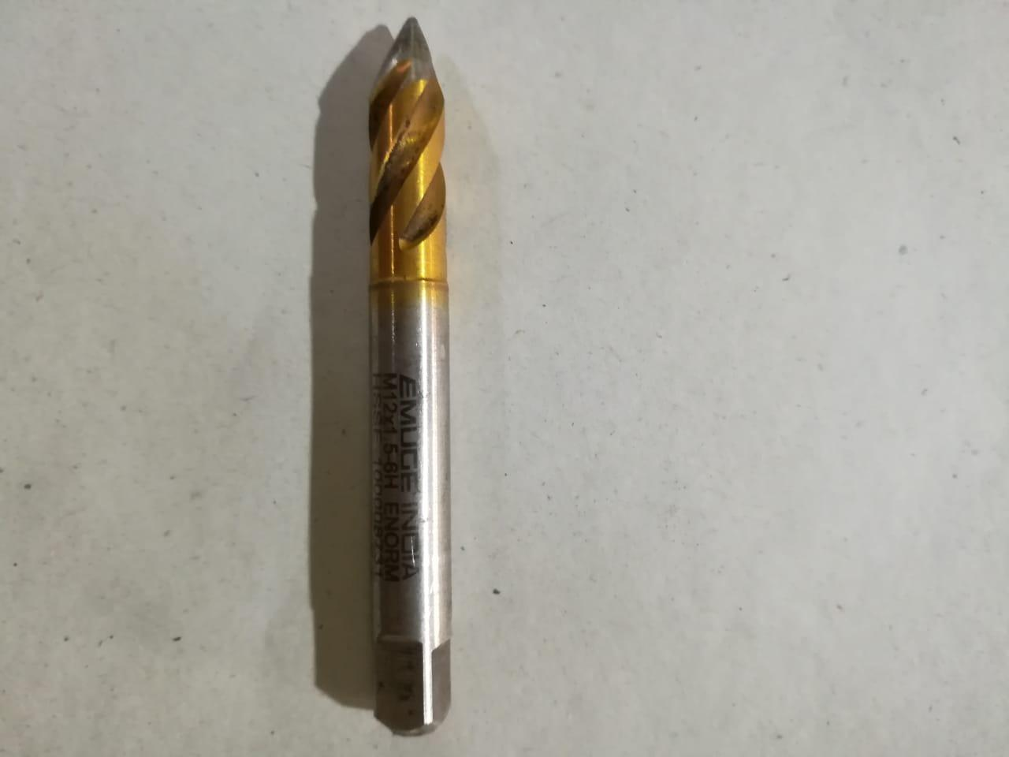

**Finishing: -**

Finishing is a broad range of [industrial processes](https://en.wikipedia.org/wiki/Industrial_process) that alter the surface of a manufactured item to achieve a certain property. Finishing processes may be employed to: improve appearance, adhesion or [wettability](https://en.wikipedia.org/wiki/Wettability), [solder ability](https://en.wikipedia.org/wiki/Soldering), [corrosion resistance](https://en.wikipedia.org/wiki/Corrosion_resistance), tarnish resistance, chemical resistance, [wear resistance](https://en.wikipedia.org/wiki/Wear_resistance), [hardness](https://en.wikipedia.org/wiki/Hardness), modify [electrical conductivity](https://en.wikipedia.org/wiki/Electrical_conductivity), remove burrs and other surface flaws, and control the surface [friction](https://en.wikipedia.org/wiki/Friction). In limited cases some of these techniques can be used to restore original dimensions to salvage or repair an item.

An unfinished surface is often called [mill finish](https://en.wikipedia.org/wiki/Mill_finish).

The edges with grinder using grinding wheel. The machine used for this operation is hand grinder. An angle grinder, also known as a side grinder or disc grinder, is a handheld power tool used for cutting, grinding and polishing. Angle grinders can be powered by an electric motor, petrol engine or compressed air.

The motor drives a geared head at a right-angle on which is mounted an abrasive disc or a thinner cut-off disc, either of which can be replaced when worn. Angle grinders typically have an adjustable guard and a side-handle for two-handed operation. Certain angle grinders, depending on their speed range, can be use*d* as sanders, employing a sanding disc with a backing pad or disc. The backing system is typically made of hard plastic, phenolic resin, or medium-hard rubber depending on the amount of flexibility desired. The time required for this operation is 20 minutes.

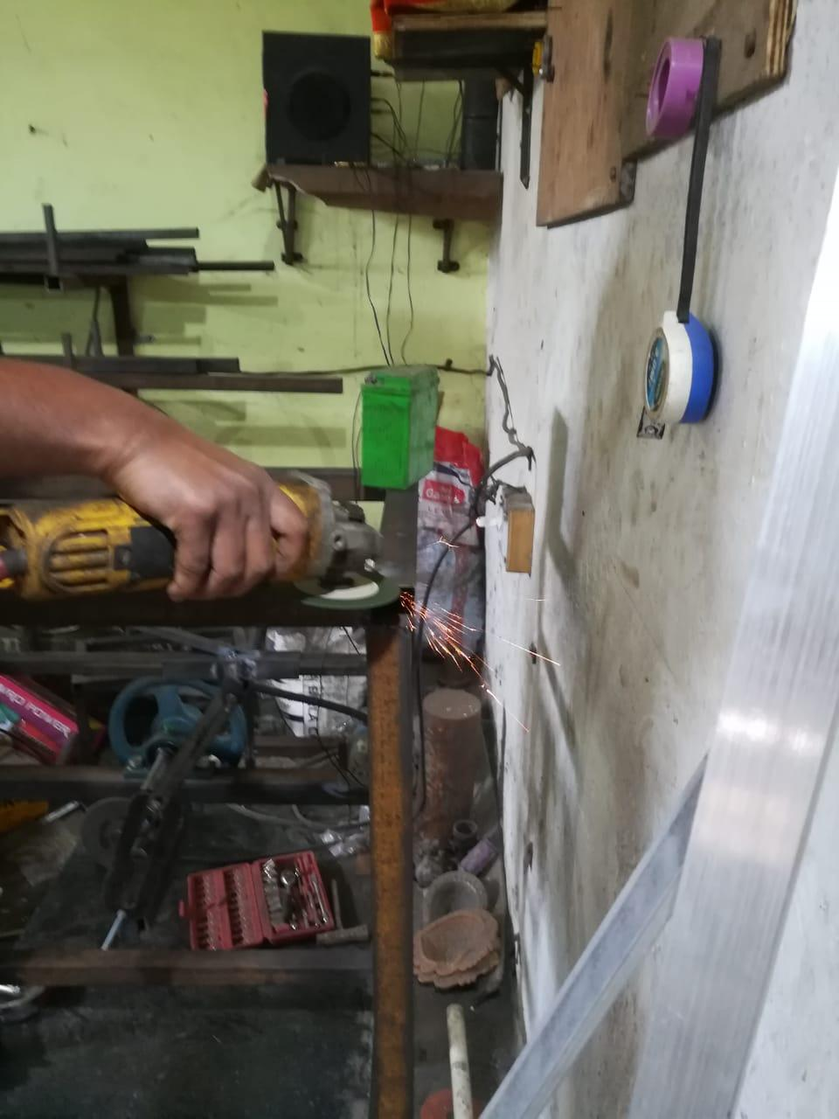

**Polishing: -**

Polishing is the process of creating a smooth and shiny surface by rubbing it or using a chemical action, leaving a surface with a significant [specular reflection](https://en.wikipedia.org/wiki/Specular_reflection) (still limited by the [index of refraction](https://en.wikipedia.org/wiki/Index_of_refraction) of the material according to the [Fresnel equations](https://en.wikipedia.org/wiki/Fresnel_equations).) In some materials (such as metals, glasses, black or transparent stones), polishing is also able to reduce [diffuse reflection](https://en.wikipedia.org/wiki/Diffuse_reflection) to minimal values. When an unpolished surface is magnified thousands of times, it usually looks like mountains and valleys. By repeated abrasion, those "mountains" are worn down until they are flat or just small "hills." The process of polishing with [abrasives](https://en.wikipedia.org/wiki/Abrasive) starts with coarse ones and graduates to fine ones.

The welded joints with hand grinder using grinding wheel. The machine used for this operation is hand grinder. With refinement, grinding becomes polishing, either in preparing metal surfaces for subsequent buffing or in the actual preparation of a surface finish, such as a No. 4 polish in which the grit lines are clearly visible. Generally speaking, those operations which serve mainly to remove metal rapidly are considered as grinding, while those in which the emphasis is centred on attaining smoothness are classified as polishing. Grinding employs the coarser grits as a rule while most polishing operations are conducted with grits of 80 and finer. If polishing is required, start with as fine a grit as possible to reduce finishing steps. There is a wide range of grinding and polishing tools on the market and advice is available from ASSDA members to assist in particular applications. Polishing operations are conducted with the abrasive mounted either on made-up shaped wheels or belts which provide a resilient backing. The base material may be in either a smooth rolled or a previously ground condition. If the former, the starting grit size may be selected in a range of 80 to 100. If the latter, the initial grit should be one of sufficient coarseness to remove or smooth out any residual cutting lines or other surface imperfections left over from grinding. In either case, the treatment with the initial grit should be continued until a good, clean, uniform, blemish-free surface texture is obtained. The initial grit size to use on a pre-ground surface may be set at about 20 numbers finer than the last grit used in grinding, and changed, if necessary, after inspection. Upon completion of the initial stage of polishing, wheels or belts are changed to provide finer grits. Polishing speeds are generally somewhat higher than those used in grinding. A typical speed for wheel operation is 2500 meters per minute. The time required for this operation is 20 minutes.

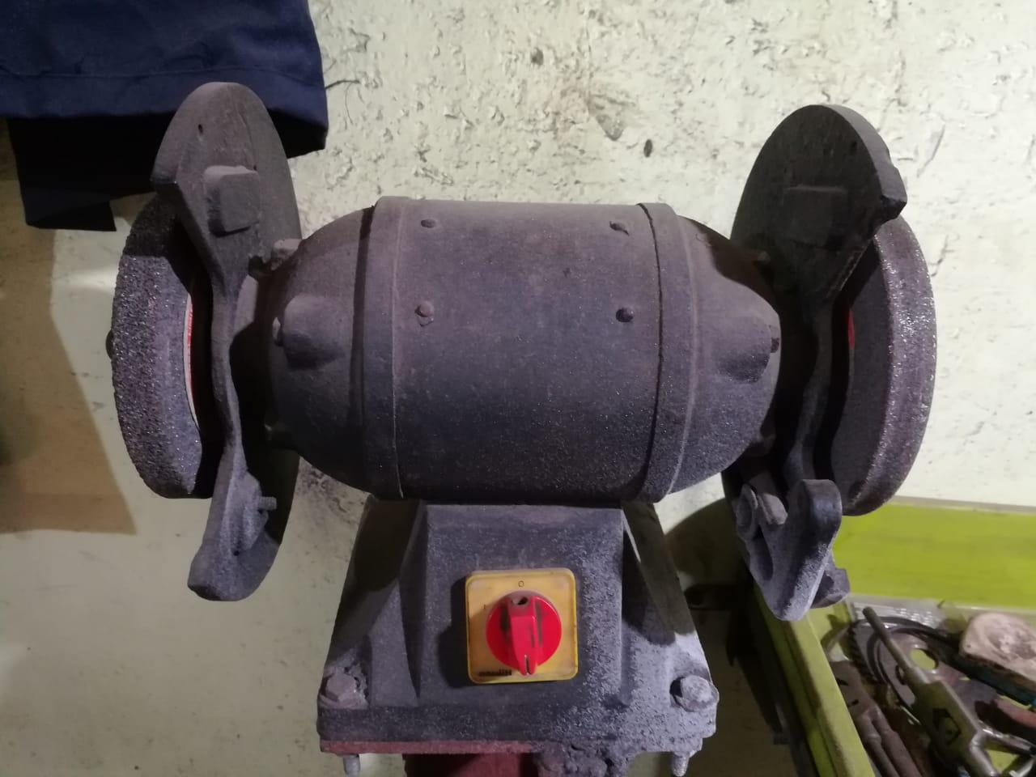

**SAFETY PRECAUTIONS:**

The following points should be considered for the safe operation of machine

And to avoid accidents: -

* All the parts of the machine should be checked to be in perfect alignment.
* All the nuts and bolts should be perfectly tightened.
* The operating switch should be located at convenient distance from the operator so as to control the machine easily.
* The inspection and maintenance of the machine should be done from time to time.
* All the nuts and bolts should be perfectly tightened.
* The operating switch should be located at convenient distance from the operator so as to control the machine easily.
* The inspection and maintenance of the machine should be done from time to time.

1. **ARDUINO CODE :-**

#include <SPI.h>

#include <MFRC522.h>

#define SS_PIN 10

#define RST_PIN 9

MFRC522 mfrc522(SS_PIN, RST_PIN); // Create MFRC522 instance.

void setup()

{

pinMode(7,1);

pinMode(6,1);

pinMode(5,OUTPUT);

pinMode(4, INPUT);

Serial.begin(9600); // Initiate a serial communication

SPI.begin(); // Initiate SPI bus

mfrc522.PCD_Init(); // Initiate MFRC522

Serial.println("Approximate your card to the reader...");

Serial.println();

digitalWrite(5, HIGH);

delay(2000);

}

void loop()

{

int ir = digitalRead(4);

// digitalWrite(5, HIGH);

// delay(100);

// Look for new cards

if ( ! mfrc522.PICC_IsNewCardPresent())

{

return;

}

// Select one of the cards

if ( ! mfrc522.PICC_ReadCardSerial())

{

return;

}

//Show UID on serial monitor

Serial.print("UID tag :");

String content= "";

byte letter;

for (byte i = 0; i < mfrc522.uid.size; i++)

{

Serial.print(mfrc522.uid.uidByte[i] < 0x10 ? " 0" : " ");

Serial.print(mfrc522.uid.uidByte[i], HEX);

content.concat(String(mfrc522.uid.uidByte[i] < 0x10 ? " 0" : " "));

content.concat(String(mfrc522.uid.uidByte[i], HEX));

}

Serial.println();

Serial.print("Message : ");

content.toUpperCase();

if (content.substring(1) == "F9 C4 E1 87") //change here the UID of the card/cards that you want to give access

{

Serial.println("Authorized access");

Serial.println();

//delay(3000);

digitalWrite(6,1);

delay(200);

digitalWrite(6,0);

delay(200);

digitalWrite(6,1);

delay(200);

digitalWrite(6,0);

delay(200);

digitalWrite(6,1);

delay(200);

digitalWrite(6,0);

delay(1000);

while(ir == 1)

{

digitalWrite(5, LOW);

delay(150);

ir = digitalRead(4);

delay(100);

}

// ir = digitalRead(4);

// if(ir == 0)

// {

digitalWrite(5, HIGH);

delay(2000);

// }

// }

}

else if (content.substring(1) == "45 7F 2C 21") //change here the UID of the card/cards that you want to give access

{

Serial.println("Authorized access");

Serial.println();

//delay(3000);

digitalWrite(6,1);

delay(200);

digitalWrite(6,0);

delay(200);

digitalWrite(6,1);

delay(200);

digitalWrite(6,0);

delay(200);

digitalWrite(6,1);

delay(200);

digitalWrite(6,0);

delay(1000);

while(ir == 1)

{

digitalWrite(5, LOW);

delay(150);

ir = digitalRead(4);

delay(100);

}

// ir = digitalRead(4);

// if(ir == 0)

// {

digitalWrite(5, HIGH);

delay(2000);

// }

}

else

{

Serial.println(" Access denied");

Serial.println();

//delay(3000);

digitalWrite(7,1);

delay(200);

digitalWrite(7,0);

delay(200);

digitalWrite(7,1);

delay(200);

digitalWrite(7,0);

delay(200);

digitalWrite(7,1);

delay(200);

digitalWrite(7,0);

delay(1000);

//

// digitalWrite(5, HIGH);

// delay(2000);

}

1. **CONCLUSION AND FUTURE SCOPE**

The automated Rotary storage system for the selected application is designed, analysed and fabricated. The system is tested and is found to work satisfactorily. It takes twenty five seconds for the shelf to complete one full rotation.

The automated racks are an efficient system which will transfer the material from higher to lower level. It can be used in wide applications for material handling for domestic, industrial as well as commercial purpose. It can be easily tailored to the applications individual needs. It optimizes the use of vertical space and also reduces the time and effort needed to bring the items kept at elevated height.

* **REFERENCES**

1. Aji Roy, “Object Sorting Robotic Arm Based on Colour Sensing”, International Journal of Advanced Research in Electrical, Electronics and Instrumentation Engineering, Vol. 3, Issue 3, March 2014.
2. GargUttam, BhowadRugved, Rahul Chorghe, Yadav Sachin, “Vertical Material Handling System”, International Journal Of Mechanical Engineering And Technology (IJMET), Volume 6, Issue 2, February 2015
3. Manas Lad, PrabhatMahamuni, PrachiMandve, SavioSequeira, Sanjay Rukhande, “ Design and Fabrication of Automated Shelves”, IJIRT, 143382, April 2016 | IJIRT | Volume 2 Issue 11 | ISSN: 2349-6002, pg 85-89
4. MakatoKanehira, TomofumiOtani, “Complete Guide to Chain”,(Handbook), U.S Tsubaki, Inc, 2016
5. ABNT NBR-14672. Dimensionamento de Estruturas de AçoConstituídasporPerfisFormados a Frio. 2017
6. [14]WebLink-http://www.dfrobot.com/wiki/index.php/TCS3200 _Color_Sensor_(SKU:SEN0101)
7. Web-Link-http://www.valinonline.com/images/support_ docs Oriental-Motor-Electromagnetic-Brake-Motors.pdf
8. VipulMore,Kiranravaria,Sahil Shah Automatic Rotary Storage Sytem Using RFID IJARIIE-ISSN(O)-2395-4395,Volume-3 issue-2,2017 (pp 5079-5080)